CONTINUOUS ASSESSMENT TEST – I ,II
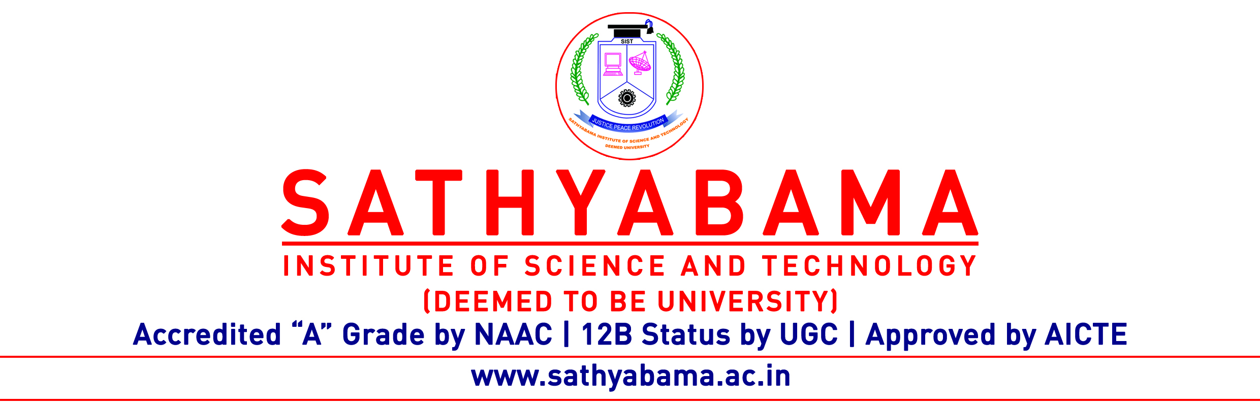
Program : CSE Max. Marks : 30
Course : B.E Time : 1 Hour
Course Code : SCS1301 Sem : V
Batch : 2018-2022 Date : 18.11.2020
Part-A Answer ALL the questions (5×2=10)

Q.No | Questions | CO (L)
 | Define operating system? | CO1(L1)
 | Discuss the user level thread with example | CO2(L1)
 | Compare Preemptive and Non Preemptive Scheduling(Any two points) | CO2(L2)
 | Summarize the race condition with suitable example | CO3(L5)
 | Differentiate internal and external fragmentation. | CO4(L3)
Part-B Answer ALL the questions (2×10=20)

Q.No | Questions | CO (L)
 | Describe the buffering with neat diagrams. Also Identify the need of buffering. | CO1(L1)
 | (OR)
 | Infer the Average Waiting time and average Turnaround time for the below processes with FCFS Scheduling | CO2(L2)
  Process | Burst Time
  P1 | 24
  P2 | 3
  P3 | 3

 | Explain the concept of dining philosopher with solutions | CO3(L4)
 | (OR)
 | Measure the page fault and hit ratio with the reference string: 1,3,0,3,5,6,3(with 3 frames, FIFO) | CO4(L5)

